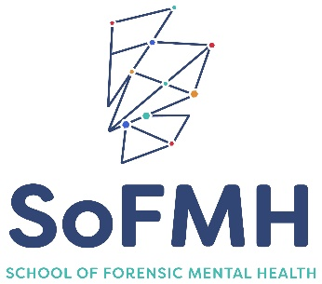

FORENSIC NETWORK RESEARCH SPECIAL INTEREST GROUP (FNRSIG)
ANNUAL CONFERENCE

Microsoft Teams
2nd November 2023

CALL FOR ABSTRACTS

Title of paper:
Name(s) of presenters:
Nature of Abstract: | Presentation ☐ Rapid Poster Presentation ☐ Poster only ☐
Student status of study presenter: | Full time Student:  ☐ Yes  ☐ No

Presentation: This is a 10 minute presentation of your work with slides to be included in a breakout session.

Rapid Poster Presentation: This is a 3 minute presentation based on a hard copy poster to be submitted on one PowerPoint slide to be presented to the audience as part of our Rapid Poster presentation session.

Contact Address (1) | Contact Address (2)
Tel:  Email: | Tel:  Email:

Details of Proposal

Abstracts should be no longer than 300 words.

By Post:
Forensic Network
The State Hospital
Carstairs
Lanark
ML11 8RP

Email:
tsh.forensicnetwork@nhs.scot

