

Report of the Care Programme Review Group
May 2010

Contents

1. Introduction 3

2. Group Membership 3

3. Group Working Arrangements 3

4. Child Protection 4

5. Protection of Adults at Risk of Harm 5

6. Suspension of Detention 5

7. Risk Management Traffic Lights Good Practice Guidance 7
With Examples

8. Identifying new Information within CPA Objectives 7

9. Audit of CPA Paperwork for Restricted Patients 7

10. Driving 8

11. Documentation of CPA Discussions 9

12. Revised CPA Documentation 9

13. Summary of Recommendations 9

Appendices
1 – NPSA Rapid Response Report 12
2 – CMO Guidance on disclosing confidential information 13
3 – Definitions of Adults at Risk of Harm 16
4 – SUS 1 Form 17
5 – Example of Programme of Visits for SUS 20
6 - Good Practice Examples for Traffic Light Contingency
6.1 High Risk 25
6.2 Transition to Lesser Security 28
6.3 Community 32
7 – CPA Minute and Other 3rd Party Information 34
8 – Revised CPA Paperwork 35

1. Introduction
Care Programme Approach (CPA) Guidance for Restricted Patients is outlined in Scottish Government CEL 13 (2007). This was a result of work undertaken by the Forensic Network in 2006. In line with the guidance forensic mental health services across Scotland use the Care Programme Approach in the management of all restricted patients and many services utilise the approach for all patients managed within mental health services.

In July 2009 The Scottish Government invited the Forensic Network to review Care Programme Approach (CPA) Documentation in light of risks outlined in the English National Patient Safety Agency Rapid Response Report: Preventing Harm to Children from Parents with Mental Health Needs. A copy of the Rapid Response Report is attached for information at appendix 1. The Government also felt it was timely to amend CPA Documentation regarding Suspension of Detention and plans to dispense with the Annex B2 and B3 forms.

In January 2010 the Scottish government further requested the group to consider how discussions within the CPA were recorded. Since the request from Scottish Government The Mental Welfare Commission published its report into the Care and Treatment of Mr F which also recommended a review of current CPA in Scotland.

It is not intended that this guidance replace The CPA guidance in CEL 13 (2007), the revised sections and additions are intended to be considered alongside the original guidance. When using the CPA clinical teams should always consider patient focussed care, recovery and social inclusion.

Dr John Crichton had been central to the development of the CPA procedures and documentation as part of the Forensic Network Group of 2006 and therefore was invited to lead this piece of work.

2. Membership
A multi-agency group was established to consider this work:

Ms Chris Clarke, Child Protection Manager, East Lothian Council
Mr Peter Clarke, CPA Manager, The State Hospital
Dr John Crichton, Lead Clinician, Orchard Clinic, Edinburgh (Chair)
Ms Fiona Currie, Scottish Government
Ms Vivienne Gration, Forensic Network Manager
Ms Catriona Wilson, Care Programming Manager, NHS Glasgow & Clyde
Ms Rosie Toal, Scottish Government
Dr Margaret Morrison, Scottish Government
Mr Gordon Stirling, Scottish Government
Dr Tom White, Lead Clinician, North of Scotland
Mr Stuart Lennox, Adult Protection Manager, City of Glasgow Council

3. Working Arrangements
The group met on two occasions, 16 September and 28 October. On both occasions not all members were able to attend, however discussions were supplemented with e-mail communications. Draft revised CPA Paperwork and Guidance was shared with the group electronically for comment November 2009 and April 2010.

The group identified a number of issues to be considered during the review process:

- Child Protection
- Protection of Adults at Risk of Harm
- Suspension of Detention Forms
- Risk Management Traffic Lights Good Practice Guidance (with examples)
- Identifying New Information within Objectives
- Audit of CPA Paperwork for Restricted Patients
- Driving
- Documentation of CPA Discussion

The Group initially did not include Child Protection and Adult Protection colleagues, but during discussions it became apparent that consultation with professionals within this field to ensure that the revised process would fit with their practices and procedures.

A draft report was circulated to the working group for comment in April 2010 and submitted to the Scottish Government for the new working arrangements to be included in the new Memorandum of Procedure for Restricted Patients in May 2010.

4. Child Protection
Child protection is everyone’s business and all NHS mental health services have existing statutory responsibilities for child protection (Chief Medical Officer, 2003). While mental illness can be compatible with good parenting, some parents with severe mental illness are at risk of harming their children (NPSA, 2009, RRR003). Although the NSPA is an English Organisation its recommendations are influential in Scotland.

In Crichton’s review of Homicides (Forensic Network Report on review of critical incident procedures in forensic services, 2007) 4% of victims are service users own children.

The group considered that forensic patients may have contact with their own and with other children (for example extended family or family of a new partner) whilst on leave from inpatient services or whilst being cared for in the community. These circumstances should also be considered within CPA process.

Members noted that there are already robust child protection policies in place and that Multi Agency Public Protection Arrangements (MAPPA) also raises issues of child protection.

While risk assessments, as part of the CPA Process, will regularly include discussions around child protection it is important to have available an independent touchstone in the form of child protection colleagues. This is an area where there can be confusion regarding confidentiality and disclosure of information. Guidance from Chief Medical Officer in 2003 on this topic is given in Appendix 2.

Recommendations

  - Risk assessment must always address risk to children even if this is a statement that there is no particular increased risk to children in that particular case.
  - Child visiting policies must be in place in forensic services and subject to clinical governance in line with arrangements outlined in CEL 2007 13 and Secure Care Standards in HDL 2006 48.
  - Whenever there is regular contact with children on Suspension of Detention or on Conditional Discharge the safety of the child must be considered at the CPA and if there are any concerns regarding risk to children this should trigger a discussion with the appropriate Child and Family Team. This may result in a Child Protection Case Conference.
  - To support consideration of child safety the CPA pro-forma will include a section on the topic which can be found on page 3 of the recommended CPA paperwork.
  - All Local Authorities have their own inter-agency Child Protection Procedures/Guidelines, which should be adhere to in all instances where there may be risk of harm to a child.

5. Protection of Adults at Risk of Harm
Part 1 of The Adult Support and Protection (Scotland) Act 2007 introduces measures to identify and protect adults at risk from harm. It defines ‘adults at risk’ and ‘harm’. Where it is known or suspected that an adult is being harmed, the Act places a duty on councils to make the necessary enquiries to establish whether or not further action is required to stop or prevent harm occurring. A general principle on intervention in an adult’s affairs requires action which is the least restrictive to the adult whilst providing benefit to him or her. Protection orders include assessment orders, removal orders and banning orders, which require approval by a sheriff. Details of the definitions outlined in the act are attached at Appendix 3.

The group decided given the progressive arrangement for vulnerable adult protection in Scotland the CPA should extend its guidance to include them.

Recommendations

  - Risk assessment must always consider adults at risk of harm even if this is a statement that there is no particular increased risk to vulnerable adults in that particular case.
  - Whenever there is regular contact with adults at risk of harm on Suspension of Detention or on Conditional Discharge the safety of the vulnerable adult must be considered at the CPA and if there are any concerns regarding risk to them this should trigger a discussion with the appropriate Adult Protection Team. This may result in a Vulnerable adult Case Conference.
  - To support consideration of adults at risk of harm the CPA proforma will include a section on the topic which can be found on page 3 of the recommended CPA paperwork, appendix 8.

6. Suspension of Detention Forms
This review of the CPA provided an opportunity to review current Suspensions of Detention (SUS) arrangements. Currently RMOs apply for SUS using Annex B3 of the Memorandum of Procedure for Restricted Patients (MOP) and report progress three monthly using Annex B4 proformas. Prior to unescorted SUS the case must be considered at MAPPA. In addition, once permission is granted the RMO must complete a SUS1 form. Given new CPA procedures much of the current system is repetitive and inefficient.

Recommendations

  - All hospitals who manage restricted patients must have policies for Suspension of Detention and absconsion subject to governance in line with arrangements outlined in CEL guidance 2007 13.
  - SUS should be included in the care plan which includes progress on SUS.
  - The risk management traffic lights should address contingencies should an adverse incident arise during SUS.
  - Annex B3 should be replaced by an unsigned SUS3 form. This should include, along with the CPA, all the information currently with the Annex B3. An example is given in appendix 4. Once approval is given by Scottish Government the SUS3 form should be signed by the RMO and Suspension of Detention can commence.
  - It is recommended that RMOs request programmes of SUS designed to be discussed and completed at CPA reviews. An example is given at Appendix 5. SUS can be requested exceptionally outwith the CPA process by letter to the Scottish Government providing feedback if appropriate on previous SUS.
  - Although freedoms within hospital grounds for patients who are restricted or are of restricted status can sometimes be granted by the RMO it is always good practice to consider this as Suspension of Detention and to involve Scottish Government. When a restricted patient is first being considered for any unescorted SUS, including within the grounds of the hospital, the multi-disciplinary team must initiate a MAPPA referral. However, unescorted leave within the secure perimeter of the State Hospital or Rowanbank Medium Secure Unit would not normally trigger such a referral.
  - When a restricted patient is first admitted, clinical teams should consider permissions in advance for any medical emergencies which might involve transfer to hospital and what arrangements and contingencies need to be in place.

Suspension of Detention Process

Is the patient in State Hospital?
Follow State Hospital Policy (Suspension of Detention Policy &Procedure)
SUS1 form to Scottish Government
MAPPA Referral and Approval
Is the patient recommended for unescorted leave?
Yes
No
Yes
Yes
No
SUS discussed in CPA & included in care plan. Adverse incident contingencies included in traffic lights

7. Risk Management Traffic Lights Good Practice Guidance (with examples)
There has been some confusion regarding the utility of Risk Management Traffic Lights (RMTL) in regard to restricted patients who have yet to reach the stage of Conditional Discharge. The RMTL are intended to distil information from formal risk assessments and give clear guidance as to what contingencies should be in place for clinical deterioration or adverse incident. It is intended to give clear guidance even to on call clinical staff who may not be familiar with the case. If the patient has not yet progressed to Conditional Discharge the RMTL have particular role in indicating when SUS should itself be suspended or in managing incidents during SUS. This will be in addition to unit policies on matters such as absconsion.

For a patient who has not yet progressed to SUS, perhaps in The State Hospital, the traffic lights may be applied to freedoms which are available, such as grounds access.

The group found examples of good practice involving RMTL at all levels of security and examples are attached at appendix 6.

Recommendations

  - Colleagues are encouraged to consider examples given within RMTL for their own cases

8. Identifying New Information within CPA Objectives
The current CPA paperwork requires that any new information within the Objectives Section is entered in a separate form.

In order to avoid unnecessary duplication and to ensure that additions and/or changes to objectives are highlighted the Group has added a column to the objectives table. This should be used to indicate whether the particular objective is:

C – Continued unchanged
R – Revised
N – New
D – Discontinued

The column also provides space for teams to include information about the change made. This should not be a whole repeat of the objective, but rather short note about what revision has been made to a revised objective.

Recommendation

  - Clinical Teams should indicate on the objectives table whether each objective is Continued, Revised, New or Discontinued. For Revised objectives it is good practice to include a short note giving details of the change made.

- Audit of CPA Paperwork for Restricted Patients
The Scottish Executive Restricted Patient team carried out an audit of CPA for conditionally discharged patients in 2006 (Hunter 2006). There were fifty (50) cases of restricted patients living in the community in Scotland at that time. In only 28 of the cases was specific CPA paperwork present. In the remaining 22 information had to be gleaned from a variety of other paperwork. The results were very disappointing. In the majority of cases there was no clear recording of even basic information as to the name of the RMO, the MHO, the ‘named person’, evidence of the existence of an Advance Statement, date of conviction/insanity acquittal or date of next CPA review.

Of particular concern with regard to issues of patient and public safety, the significant majority of cases had no recorded statement regarding risk present, no clear identification of risk factors and no contingency plan. There was no clear list of those in attendance and participation of the police seemed to be exceptionally rare.

From this examination of CPA it was clear that arrangements were unsatisfactory and although there were pockets of good practice, often at specific forensic centres, overall CPA was not implemented fully. Even where it was operational, essential information, especially regarding risk management, was often absent.

A re audit was carried out by Dr Alex Quinn in November 2009 on conditionally discharged restricted patients. The results across Scotland showed much improvement. The majority of conditionally discharged patients had appropriate CPA paperwork (92%) although a number of regions used an altered format which made accessing the information more difficult to those unfamiliar with regional variations.

The recording of contact details had much improved with 98% of cases having a recorded MHO, and care co-ordinator. Only one patient had no recorded RMO. Two areas of deficit were noted. Only 78% of cases had a recorded community psychiatric nurse, and 61% a named police contact.

Involvement in multi agency public protection has been a recent development in the management of Scottish restricted patients. MAPPA was implemented to manage sex offenders in April 2007 and restricted patients were included from April 2008. According to the available CPA paperwork 9 cases were not subject to these arrangements. The relative youth of these developments may reflect these anomalies.

A concern in the initial audit had been that of risk assessment. This was probably the most significant area of improvement. Only one case did not have a recorded statement regarding risk, with risk factors and contingency plans identified.

The majority of cases (94%) used the traffic light system. This has proved easy to use and has the advantage of brevity compared to lengthy risk assessments.

In summary, there was a significant improvement in both documentation of risk, contingency plans and the identification of key members of the multidisciplinary team. Services had largely adhered to the approved format, but not without a degree of local adaptation.

Recommendation
9.1 There should be an ongoing programme of audit of CPA Paperwork, with at least one review each year. This provides an opportunity to ensure that CPA is being utilised effectively

10. Driving

In Crichton’s Review of Homicides (Forensic Network Report on review of critical incident reviews, 2007) 5% of deaths of mental health service users occurred when driving. In 2009 there was a high profile case of a service user (Hannah Saaf) having killed a young boy by dangerous driving.

Patients who drive have responsibility to contact the DVLA but clinical teams should consider contact with DVLA medical section and disclose information as per guidance outlined in Appendix 2.

Recommendations
  - Risk assessment must always address risk of driving if this is a statement that there is no particular increased risk in that particular case.
  - To support consideration of driving by restricted patients the CPA pro-forma will include a section on the topic which can be found on page 3 of the recommended CPA paperwork.

11. Documentation of CPA Discussion
There has been variable practice with keeping minutes of discussion at CPA meetings. In some instances teams provide a summary, other teams consider CPA document as the minute. A minute should be provided for all CPA Meetings. This provides details of what discussions were focussed around as well as contextualising information it gives some justification for the risk management plan. The CPA minute, excluding any pre-CPA minute containing sensitive or 3rd party information, should be circulated to the whole group. It is also important to have a record when there are disagreeing views to allow scrutiny by Scottish Government. In different cases it is expected there will be differences of opinions. It is often more appropriate to air these views within a pre-CPA minute. A record of the discussion should be attached as an additional page at the back of the CPA Document.

Clinical teams should not be wary of documenting differences of opinion, it shows the team demonstrates effective reflective practices, disagreements where they do occur should be shared with Scottish Government as part of its monitoring role.

Recommendation

11.1 Clinical Teams should have a pre-CPA meeting to discuss differences of opinion; a record of the discussion should be attached as an additional page at the back of the CPA document. An example is attached at appendix 6.
11.2 All CPA minutes should contain a record of the discussion (Page 9)

12. Revised CPA Documentation

A revised copy of the CPA documentation which includes additional sections relating to the guidance outlined is attached at Appendix 8.

Recommendation

12.1 Clinical Teams should use the revised CPA documentation for all CPA meetings.

13. Summary of Recommendations

Child Protection

4.1 | Risk assessment must always address risk to children even if this is a statement that there is no particular increased risk to children in that particular case
4.2 | Child visiting policies must be in place in forensic services and subject to clinical governance in line with arrangements outlined in CEL 2007 13 and Secure Care Standards in HDL 2006 48.
4.3 | Whenever there is regular contact with children on Suspension of Detention or on Conditional Discharge the safety of the child must be considered at the CPA and if there are any concerns regarding risk to children this should trigger a discussion with the appropriate Child and Family Team. This may result in a Child Protection Case Conference.
4.4 | To support consideration of child safety the CPA pro-forma will include a section on the topic which can be found on page 3 of the recommended CPA paperwork.
4.5 | All Local Authorities have their own inter-agency Child Protection Procedures/Guidelines, which should be adhere to in all instances where there may be risk of harm to a child.

Protection of Adults at Risk of Harm

  - Risk assessment must always consider adults at risk of harm even if this is a statement that there is no particular increased risk to vulnerable adults in that particular case.

  - Whenever there is regular contact with adults at risk of harm on Suspension of Detention or on Conditional Discharge the safety of the vulnerable adult must be considered at the CPA and if there are any concerns regarding risk to them this should trigger a discussion with the appropriate Adult Protection Team. This may result in a Vulnerable adult Case Conference.

  - To support consideration of adults at risk of harm the CPA proforma will include a section on the topic which can be found on page 3 of the recommended CPA paperwork, appendix 8.

Suspension of Detention Forms

  - All hospitals managing restricted patients must have policies for Suspension of Detention and absconsion subject to governance in line with arrangements outlined in CEL 2007 13 and Secure Care Standards in HDL 2006 48.

  - SUS should be included in the care plan which includes progress on SUS.

  - The risk management traffic lights should address contingencies should an adverse incident arise during SUS.

  - Annex B3 should be replaced by an unsigned SUS3 form. This should include, along with the CPA, all the information currently with the Annex B3. An example is given in appendix 4. Once approval is given by Scottish Government the SUS3 form should be signed by the RMO and Suspension of Detention can commence.

  - It is recommended that RMOs request programmes of SUS designed to be completed at CPA reviews. An example is given at Appendix 5. SUS can be requested exceptionally outwith the CPA process by letter to the Scottish Government providing feedback if appropriate on previous SUS.

  - Although freedoms within hospital grounds for patients who are restricted or are of restricted status can sometimes be granted by the RMO it is always good practice to consider this as Suspension of Detention and to involve Scottish Government. . When a restricted patient is first being considered for any unescorted SUS, including within the grounds of the hospital, the multi-disciplinary team must initiate a MAPPA referral. However, unescorted leave within the secure perimeter of the State Hospital or Rowanbank Medium Secure Unit would not normally trigger such a referral.

  - When a restricted patient is first admitted, clinical teams should consider permissions in advance for any medical emergencies which might involve transfer to hospital and what arrangements and contingencies need to be in place.

Risk Management Traffic Lights Good Practice Guidance

  - Colleagues are encouraged to consider examples given within RMTL for their own cases

Identifying New Information Within CPA Objectives

  - In order to avoid unnecessary duplication and to ensure that additions and/or changes to objectives the Group has added a column to the objectives table. This should be used to indicate whether the particular objective is:

C – Continued unchanged
R – Revised
N – New
D – Discontinued

Audit of CPA Paperwork for Restricted Patients

  - There should be an ongoing programme of audit of CPA Paperwork, with at least one review each year. This provides an opportunity to ensure that CPA is being utilised effectively

Driving

  - Risk assessment must always address risk of driving if this is a statement that there is no particular increased risk in that particular case.

  - To support consideration of driving by restricted patients the CPA pro-forma will include a section on the topic which can be found on page 3 of the recommended CPA paperwork.

Documentation of CPA Discussion

  - Clinical Teams should have a pre-CPA meeting to discuss differences of opinion; a record of the discussion should be attached as an additional page at the back of the CPA document.

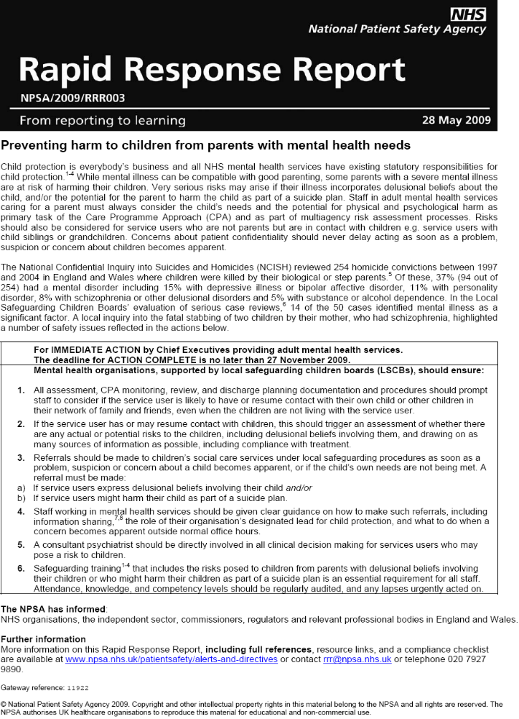
APPENDIX 1

APPENDIX 2

Guidance on disclosing confidential information
Guidance of confidentially and disclosure of information

The main guidance available to doctors on confidentially comes from the General Medical Council in a report entitled ‘Confidentiality; protecting and providing information’, dated April 2004. The General Medical Council is currently in a consultation exercise with regards to an update of that guidance.

The GMC guidance begins with the principal that patients have the right to expect that information about them will be held in confidence by their doctors. Confidentially is central to trust between doctors and patients. Without assurances about confidentially, patients may be reluctant to give doctors the information they need in order to provide good care. There are, however, limits to medical confidentially.

There is certain information where disclosure is required by law, for example in the area of suspected communicable disease. Doctors must also disclose information if ordered to do so by a judge but a doctor should object to the judge if attempts are made to compel the doctor to disclose what appears to the doctor to be irrelevant material. Doctors must not disclose personal information to a third party, such as a solicitor, police officer, or officer of a court, without the patient’s expressed consent, except in certain circumstances. Personal information may be disclosed in the public interest without the patient’s consent and in exceptional cases where patients have withheld consent, where the benefits to an individual or to society of the disclosure outweigh the public and the patient’s interests in keeping the information confidential.

In considering whether information should be disclosed without consent from the patient, a doctor must weigh the possible harm both to the patient and the overall trust between doctors and patients, against the benefits which are likely to arise from the release of information. Before considering whether a disclosure of information in the public interest would be justified, the doctor must be satisfied that identifiable data is necessary. An attempt should be made to seek the patient’s consent prior to disclosure unless it is not practicable to do so. The examples of impracticality include patient’s who are incompetent to give consent, if medical records are of such age that it would be unreasonable to trace the patients involved, that the patient has been or may be violent, if obtaining consent will undermine the purpose of the disclosure (e.g. disclosures in relation to crime), or the action required swift disclosure and there was insufficient time to contact the patient. In cases where there is a serious risk to the patient or others, disclosures may be justified even when patients have been asked to agree to a disclosure but have withheld their consent. Doctors should inform patients that a disclosure will be made whenever it is practicable to do so. The doctor must document in the patient’s records what steps have been taken to seek or obtain the consent and the reasons for disclosing the information without consent.

Ultimately, the GMC recognises that the “public interest” can be determined only by a court but the GMC may also require a doctor to justify his or her actions if a complaint about disclosure of identifiable information occurs without a patient’s consent.

Paragraph 27 of the guidance states,

“Disclosure of personal information without consent may be justified in the public interest where failure to do so make expose the patient or others to risk of death or serious harm. Where the patient or others are exposed to a risk so serious that it outweighs the patient’s privacy interests, should seek consent to disclose where practicable. If it is not practicable or to seek consent, you should disclose information promptly to an appropriate person or authority. You should generally inform the patient before disclosing the information. If you seek consent and the patient withholds it, you should consider the reasons for this, if any are provided by the patient. If you remain of the view that disclosure is necessary to protect a third party from death or serious harm, you should disclose information promptly to an appropriate person or authority. Such situations arise, for example, where a disclosure may assist in the prevention, detection or prosecution of a serious crime, especially crimes against the person, such as abuse of children.”

There is further General Medical Council guidance in their document ‘Good Medical Practice’ published in 2006. At paragraph 37 it states,

“Patients have a right to expect that information about them will be held in confidence by their doctors. You must treat information about patients as confidential, including after a patient has died. If you are considering disclosing confidential information without a patient’s consent, you must follow the guidance in ‘Confidentiality; Protecting and Providing Information’.

There is also guidance on this matter from the Royal College of Psychiatrists in their publication ‘Good Psychiatric Are; Confidentiality and Information Sharing’, council report CR133, 2006. This document has a specific section on requests by the police for information at page 10,

“There is sometimes a tension between the police desire for further information for public protection purposes and the medical duty of confidentially. Requests for information should be treated in a similar manner, irrespective of the agency they originate from. The fact that a request comes from the police does not in itself have any bearing on a decision whether or not to disclose. Police statutory powers to require disclosure are very limited… Disclosure must otherwise be justified by public interest criteria… Psychiatrists must be able to justify any agreement or refusal; it is good practice to keep a written record of the justification.”

At page 24 the guidance goes on,

“There are instances where the doctor may be in receipt of information and is required to make a judgement on whether or not the public interest served by disclosure outweighs his or her duty of confidentiality. Disclosure of confidential information to third parties may be justifiable in the public interest on the basis of the benefit it brings or the harm averted by disclosure. While there is, in civil law, no general duty to prevent a third party from causing damage to another, a duty of care may be owed if there is proximity between a patient and a potential victim where the latter is ‘identifiable’ or ‘identified’ (Court of Appeal: Palmer versus Tees Health Authority 1999). If a professional decision was challenged in the courts by an aggrieved party under common law, the court will take careful account of the opinion of fellow doctors or the guidance of professional organisations as to whether a decision concerning disclosure was within the reasonable practice of a responsible body of medical practitioners.

It may be sometimes be justifiable for a doctor to pass on patient information without consent or statutory authority. Such situations include;

- Where serious harm may occur to a third party, whether or not criminal offence, e.g. threat of serious harm to a named person, on the expectation that disclosure would have the desired effect of preventing the harm …
- When without disclosure the task of the police in preventing or detecting a serious crime would be predigest or delayed. The General Medical Council in its [earlier] guidance on confidentiality (2000; paragraph 37, bullet point 3) defines ‘serious crimes’ as ones that ‘will put someone at risk of death or serious harm, and will usually be crimes against the person such as the abuse of children.’
- When without disclosure the task of prosecuting a serious crime would be predigest or delayed (e.g. a patient tells you that he committed a serious crime several years ago). Or conversely in a situations where it is necessary to the defence of a case to ensure that there is no miscarriage of justice…

There is also guidance for the NHS in Scotland in the document ‘NHS Code of Practice of Protecting Patient Confidentiality’, published by the Scottish Executive in 2003. At paragraph 7.6 it states,

There will be occasions when staff are asked to disclose information without consent, e.g in child protection or suspected serious crime. The clinician in charge must be prepared to balance the considerations for and against disclosure in the interests of the patient and any third party; justify and record each decision to disclose or withhold. It will therefore be a matter for the clinicians best judgement as well as legal and professional guidance. Decisions should be taken on a case by case basis in the light of best available information, which may include advice from the Data Protection Officer, Cauldicot or Information Guardian. Wherever possible the patient should be informed what information has been disclosed and to who.”

APPENDIX 3

Definitions from the Adult Support and Protection (Scotland) Act 2007:

The legislation gives the following definitions;
- In terms of Section 53 of the Act, “adult” means a person aged 16 or over.
- Section 3(i) defines “adults at risk” as adults who:
  - are unable to safeguard their own well-being, property, rights or other interests;
- are at risk of harm; and
- because they are affected by disability, mental disorder, illness or physical or mental infirmity, are more vulnerable to being harmed than adults who are not so affected.

It is important to stress all 3 elements of the definition must be met.
- Section 3(2) identifies that an adult is at risk of harm if;
another person’s conduct is causing (or is likely to cause) the adult to be harmed, or
- the adult is engaging (or is likely to engage) in conduct which causes (or is likely to cause) self harm.

That is the definition of “adults at risk” also requires an assessment about the “risk of harm” to the individual from the outset.
- Section 53 states harm includes all harmful conduct and, in particular includes:
  - conduct which causes physical harm
  - conduct which causes psychological harm (for example by causing fear, alarm or distress)
  - unlawful conduct which appropriates or adversely affects property, rights or interest (for example theft, fraud, embezzlement or extortion),
  - conduct which causes self harm.

APPENDIX 4
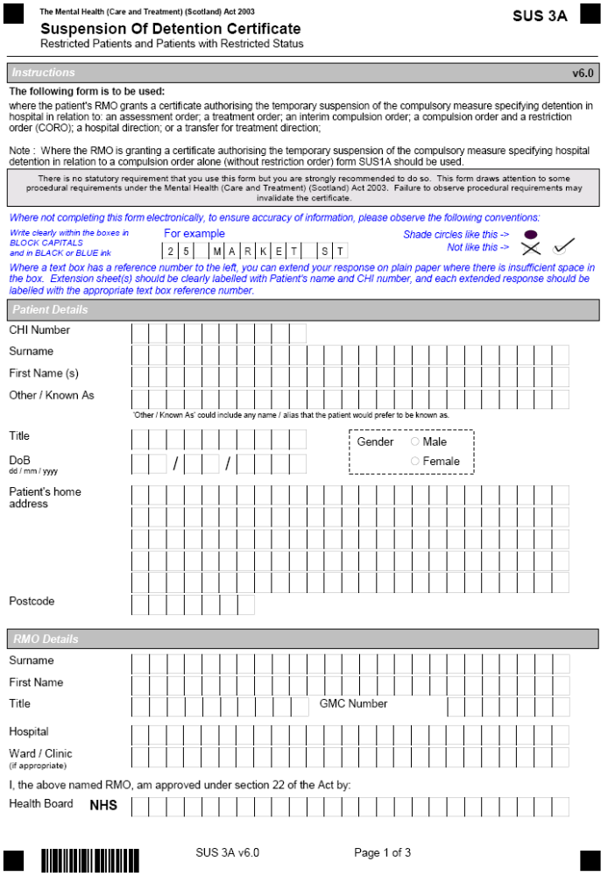

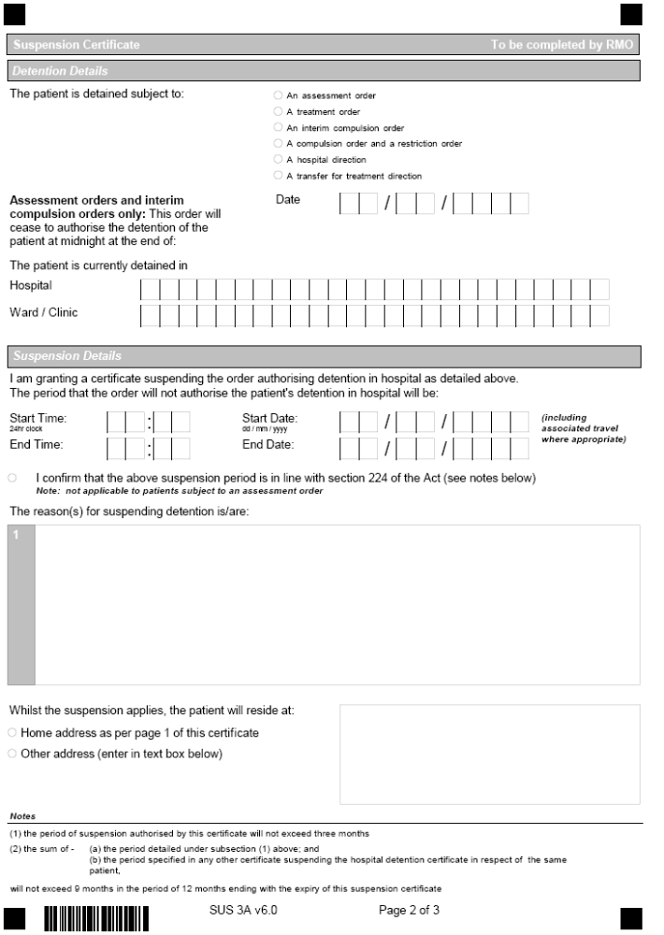

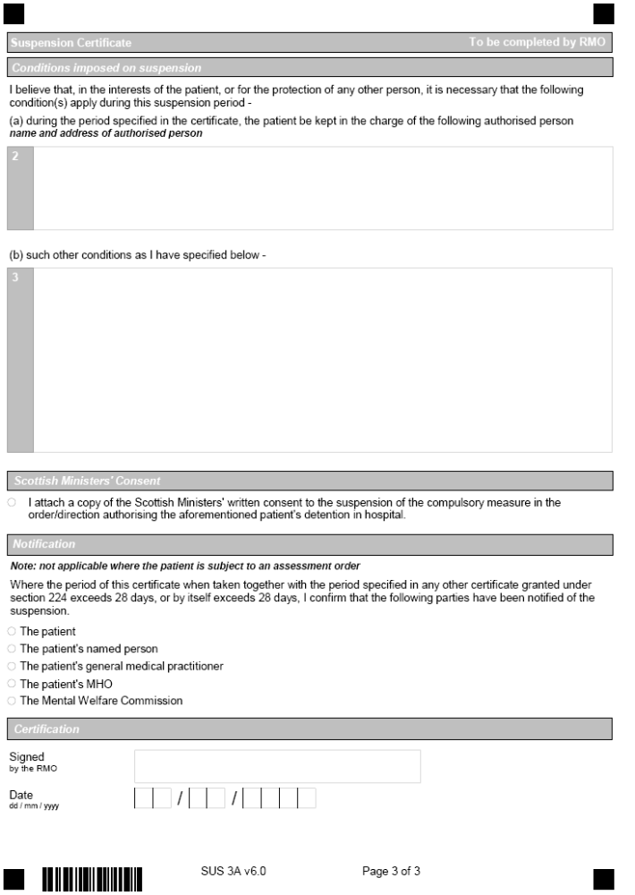

APPENDIX 5.1


Suspension of Detention Plan

Name |  | Date of Birth
Ward |  | Status
RMO |  | Date of Submission

The goal of this Suspension of Detention programme is to allow you to practice having time out of the ward with staff. It is about showing that you can cope with one stage before moving to the next.

Definitions
Suspension of detention (SUS); time outwith the unit within the boundaries of the hospital grounds, time outwith the hospital grounds, area identified within the pass plan
Identified areas; agreed by patient and the Clinical Team as locations useful to ongoing rehabilitation.
Escorted; accompanied by a member of Orchard Clinic staff, or student where approved by the clinical team. Escort will be carried out following the relevant policy and any instructions specified in the pass plan, utilising two way radio or mobile telephone. Patients may progress to family escort - this will be specified in the programme.
Duration / Frequency; Individual must return to the ward for at least 30mins between separate SUS. The agreed time may be divided into shorter durations of SUS, but total must not exceed the agreed limit.

The pass plan will be reviewed every fortnight within the clinical team meeting and progression agreed as appropriate.

Current Suspension of Detention Program

Existing Approved Pass and Leave of Absence
Type of Escort | Location
Unescorted | None
Escorted (with a member of staff) | None
Suspension of Detention Program

Stage | Additions/changes to previous stage pass/leave of absence  (to be reviewed every fortnight within the clinical team meeting with progression agreed as appropriate)  **It is expected that you will use your suspension of detention out with group/individual session times** | Clinical Team Signature | Date agreed
1 | 1 x 15min escorted pass daily in hospital grounds excluding
2 | 1 x 30min escorted pass daily in hospital grounds, excluding
3 | 1 x 60min escorted pass daily in hospital grounds, excluding. Can be taken as two 30mins.

APPENDIX 5.2

Suspension of Detention Plan

Name |  | Date of Birth
Ward |  | Status
RMO |  | Date of Submission

The goal of this Suspension of Detention programme is to allow you to practice having time out of the ward with staff. It is about showing that you can cope with one stage before moving to the next.

Definitions
Suspension of detention (SUS); time outwith the unit within the boundaries of the hospital grounds, time outwith the hospital grounds, area identified within the pass plan
Identified areas; agreed by patient and the Clinical Team as locations useful to ongoing rehabilitation.
Escorted; accompanied by a member of Orchard Clinic staff, or student where approved by the clinical team. Escort will be carried out following the relevant policy and any instructions specified in the pass plan, utilising two way radio or mobile telephone. Patients may progress to family escort - this will be specified in the programme.
Duration / Frequency; Individual must return to the ward for at least 30mins between separate SUS. The agreed time may be divided into shorter durations of SUS, but total must not exceed the agreed limit.

The pass plan will be reviewed every fortnight within the clinical team meeting and progression agreed as appropriate.

Current Suspension of Detention Program

Existing Approved Pass and Leave of Absence
Escorted | 1 x 90min escorted pass daily (in hospital grounds, excluding )- Accessing Hive, hospital shop, walk in grounds, veranda club etc  This may also be taken as 1 x 1hr and 1 x 30 mins or 3 x 30 mins. Male or female escort
Unescorted | None
Suspension of Detention Program

Stage | Additions/changes to previous stage pass/leave of absence  (to be reviewed every fortnight within the clinical team meeting with progression agreed as appropriate)  **It is expected that you will use your suspension of detention out with group/individual session times** | Clinical Team  Signature | Date agreed
1 | With male or female escort  - Add 1 x 1 hour escorted pass to _____once weekly (shops, library, coffee etc)  - Increase escorted leave within hospital grounds (excluding) to 2 x 1 hour escorted pass in hospital grounds daily. Can be taken as 2hours, 2 x 60min or in 30min periods as required. (Suggestions for pass; consider groups at the Hive, walk, shop, pool, referral to physiotherapy gym)
2 | - Add in 1 x 1 hour escorted pass to___ twice weekly (shops, library, coffee)  - As appropriate on a weekly basis add in 3 hours escorted pass specifically for the purpose of attending hospital based groups/projects i.e. woodwork, physiotherapy gym groups  Continue  - Continue escorted leave within hospital grounds (excluding) of 2 x 1 hour escorted pass in hospital grounds daily
3 | - Add in 1 x 1 hour escorted pass to _____daily (shops, library, coffee)  Continue  - As appropriate on a weekly basis add in 3 hours escorted pass specifically for the purpose of attending hospital based groups/projects i.e. woodwork, physiotherapy gym groups  - Continue escorted leave within hospital grounds (excluding) of 2 x 1 hour escorted pass in hospital grounds daily
4 | Add in  - 3 hours weekly escorted pass with Out and About group (Occupational Therapy facilitated group within ______ area - accessing community resources i.e. art galleries, city parks etc)  Continue  - 1 x 1 hour escorted pass to _____ daily (shops, library, coffee)  - As appropriate on a weekly basis add in 3 hours escorted pass specifically for the purpose of attending hospital based groups/projects i.e. woodwork, physiotherapy gym groups  - Continue escorted leave within hospital grounds (excluding ) of 2 x 1 hour escorted pass in hospital grounds daily

APPENDIX 5.3
Suspension of Detention Plan

Name |  | Date of Birth
Ward |  | Status
RMO |  | Date of Submission
The goal of this Suspension of Detention programme is to allow you to practice having time out of the ward with staff. It is about showing that you can cope with one stage before moving to the next.

Definitions
Suspension of detention (SUS); time outwith the unit within the boundaries of the hospital grounds, time outwith the hospital grounds, area identified within the pass plan
Identified areas; agreed by patient and the Clinical Team as locations useful to ongoing rehabilitation.
Escorted; accompanied by a member of Orchard Clinic staff, or student where approved by the clinical team. Escort will be carried out following the relevant policy and any instructions specified in the pass plan, utilising two way radio or mobile telephone. Patients may progress to family escort - this will be specified in the programme.
Duration / Frequency; Individual must return to the ward for at least 30mins between separate SUS. The agreed time may be divided into shorter durations of SUS, but total must not exceed the agreed limit.
The pass plan will be reviewed every fortnight within the clinical team meeting and progression agreed as appropriate.

Current Suspension of Detention Program

Existing Approved Pass and Leave of Absence
Escorted | - 1 x 1 hour five times a week to physiotherapy gym  - 1 x 1 hour daily to church centre, hospital shop or walk around grounds  - 2hour 2 x week on hospital grounds for specified activities (eg. pool competition)  - Ward Groups – facilitated fortnightly- Walking Group (3 hours weekly) and Fishing Group (6 hours monthly) escorted within Lothian  - 4 hours once a fortnight to visit local cinema escorted  - Escorted attendance at sports centres in Scotland to play hospital 5 a side football. (Max 8 hours twice per month)  - Escorted outing to visit __in ___ 1 x month for 4 hours
Unescorted | - 1 hour unescorted to ___ 2 x week  - Weekly attendance at hospital 5-side football at ____, ____ (Friday 11.30-3.00). Ward staff to take to drop of at ____, _____ and collect from there. Unescorted whilst at group.  - Unescorted to _____ 1 hour daily  - ________ gym unescorted 3 x 2 hours weekly  - Attendance at swimming pool unescorted- 3 hours weekly (will cycle or bus there)  - Unescorted on hospital grounds to 2 x 1 hour daily ( 1 hour in am , 1 hour in pm)  - Unescorted to ______ town centre for 3 hours 1 x week (café, music shops, internet)  - Weekly attendance at college 8-6pm for course
Suspension of Detention Program

Stage | Additions/changes to previous stage pass/leave of absence  (to be reviewed every fortnight within the clinical team meeting with progression agreed as appropriate)  **It is expected that you will use your suspension of detention out with group/individual session times** | Clinical Team Signature signature |  | Date agreed
1 | Change current unescorted on hospital grounds to unlimited with a purpose (e.g walking, pool, computing)  Change attendance at 5-side- football to unescorted
2 | Add any specific arranged study groups at college up to 2 x 4 hours a week unescorted
3 | Increase unescorted attendance at Commonwealth pool to 2 x 3 hours week
4 | Change 4 hours escorted fortnightly to cinema to 4 hours weekly unescorted
5 | Increase unescorted attendance at _______ gym to 3 hours 3 x week
6 | Change unescorted weekly to town to 3 hours daily with a purpose (e.g. shops, gardens, bowling)
7 | Increase escorted leave to up to 8 hours daily within Scotland for specific rehabilitation purposes (e.g. unit groups, outings such as football, appointments)

Appendix 6.1 - In Patient Undertaking Suspension of Detention

TRAFFIC LIGHT CONTINGENCY PLAN
Issue | Early Warning Signs (Relapse Indicators) | Contingency Actions
Symptoms of Mental illness  (Note patient has been symptom free for 3 years) | No symptoms of psychosis | Continue with current care plan.
 | Some negative symptoms and an increased level of suspiciousness | Inform RMO on next working day; Potential need to review. Convene CPA. Need to monitor and increase supervision levels.
 | Clear evidence of psychotic relapse. | Immediately advise RMO or duty consultant if out of hours. Advise Scottish Gov. Health Division (SGHD). Urgent consideration for readmission.
Substance Misuse | Shows no signs of using illicit drugs or alcohol. | Continue with current care plan.
 | Showing an interest in Alcohol | Refer to CPA. Consider 1:1 Alcohol counselling.alongside AA group Increase frequency of alcohol tests.
 | Positive alcohol screen.  Appears intoxicated | . Immediately advise RMO (or duty consultant if out of hours) and SGHD. Urgent consideration for readmission
Engagement with ongoing anger management and sexual violence risk reduction group work programme | Consistent Involvement | Continue with current care plan.
 | Erratic attendance, does not engage with programmes. | Need to review through CPA process. Consider 1:1 input.
 | Disengages | Immediately advise RMO (or duty consultant if out of hours). Advise SGHD. Urgent reassessment required.
Violence to staff or patients  (Note history of extreme aggression and violence) | No evidence of threats or aggression | Continue with current care plan.
 | Threatening (covertly) or aggressive behaviour | Immediately advise RMO or duty consultant if out of hours. Advise SGHD. Urgent CPA review. Consider readmission
 | Acts or threats of violence, carrying weapon, | Immediately advise Police, RMO (or duty consultant if out of hours). Advise SGHD. Readmission. Urgent CPA review.

Risk of absconscion) | Compliant with treatment, returns on time from pass | Continue with current care plan.
Risk of absconscion) | Pushing boundaries; suspicious phone calls and returning late from pass | Review level of observation and free time. Consider urine drug test
Risk of absconscion) | Absconding from pass | Immediately advise Police, RMO (or duty consultant if out of hours). Advise SGHD. Readmission. Suspend care plan. Review levels of observation and levels of security. Urgent CPA review.

Sorted by risk level (anonymised real examples)

CONTINGENCY PLANS - Transfer from high to medium security
PRESENTATION | RISK GRADING | AGREED RESPONSE
- Cooperative and compliant.  - Participating in all therapeutic and occupational activity  - Listening to the advice of staff  - Coping with support and supervision without complaint  - No evasion of support and supervision  - Addressing problems directly with appropriate person or seeking help to do so | GREEN | - Continue with current care plan and agreed levels of supervision  - Continue to progress increasing levels of responsibility and community access while carefully considering risks and risk management strategies to ensure public safety
- Displaying an antiauthoritarian attitude periodically  - Making unfounded accusations against nursing staff (e.g. bullying etc.)  - Suspicion of trying to evade supervision  - Arguing about level of support and supervision  - Arguing about security procedures  - Taking problems to another to solve rather than addressing directly or seeking help to do so. | AMBER | - Continue with current care plan but monitor carefully  - Attempt to address any expressed or observed concerns through discussion  - Do not resolve the issues for xxx but assist him to resolve the issues for himself  - Only progress community access at a slow pace while continuing to address any risk through robust risk management strategies
- Active evasion of supervision  - Rejection of advice from staff  - Threats to use his “ace card” or explicit threats towards staff  - Open aggression towards staff  - Total withdrawal of cooperation  - Actual physical assault | RED | - Abandon community access  - Review presentation and increase level of observation where necessary.  - Progression of Care plan suspended until sufficient level of cooperation and compliance is resumed  - Staff will actively pursue the origins of the deterioration of the therapeutic alliance with Damien

APPENDIX 6.2 - Transition to Lesser Security

CONTINGENCY PLANS - Transfer from high to medium security
Issue | Early Warning Signs (Relapse Indicators) | Contingency Actions
Symptoms of Mental illness | Green: No Symptoms of mental illness, compliant with medications | Continue current care and treatment
Symptoms of Mental illness | Amber: Increase in suspiciousness/ persecutory ideation, heightened state of arousal, disengagement from services | RMO and Clinical Team to review current treatment
Symptoms of Mental illness | Red: Persecutory delusions including those about the IRA, Auditory hallucinations, hostile – believing wife to be a double ( Capgras delusion) | Urgent review of care and treatment
Substance Misuse | Green: Abstinent from alcohol and substances, maintaining peer support via AA groups/ sponsor. Good insight evidenced into impact of substance use on offending behaviour/mental health. | Continue current care and treatment
 | Amber: Opportunities to use alcohol or substances, and suspicions that this may be the case. Perhaps seeking or acquiring alcohol/ substances in hospital setting. Associating with known users or negative influences from the past. Diminishing insight into impact of misuse. | Clinical team to monitor and review. Need for substance misuse input from services. RMO to be advised of current situation. Associations, grounds access and suspension of detention requests to be reviewed
 | Red: Clear evidence that alcohol/substances are being consumed/ acquired or supplied to. Noticeable impact on mental health, behaviours and attitudes. Potential for violence increased. | Urgent review of care and treatment
Engagement with treatment | Green: Fully engaged and compliant with treatment and services. Values input and open in communications with staff. | Continue current care and treatment
Engagement with treatment | Amber: Evidence of some suspiciousness/persecutory beliefs or attitude to contact. Still engaging but concerns being noted by staff. Some evidence of selective disengagement from specific services. | RMO and Clinical Team to review current treatment  Engage in discussing the issues he may have with particular staff/services
Engagement with treatment | Red: Disengagement from services and clear evidence of mental state deterioration. Open suspicions and reference to delusional material. | Urgent review of care and treatment
Violence to staff or patients | Green: Mental State stable, no signs of disengagement and compliant with care and treatment. Verbal responses appropriate to given situation. | Continue current care and treatment
Violence to staff or patients | Amber: Evidence of minor verbal hostility not in keeping with situation, or appropriate to interactions from others. Suspiciousness and feelings of persecution.  Becoming dissatisfied with his progress/ situation.  Previous history of fractious and difficult presentation in prison. | Clinical Team to review situation  Engage in work to address his attitude. Review mental state, compliance with medication
Violence to staff or patients | Red: Actual violence, threatened violence or verbal hostility of a serious nature.  Conversely, becoming more withdrawn, introspective and suspicious when interacting with others. | Urgent review of care and treatment  Consider risk to self (previous hanging attempt in prison environment – 1990) as well as high potential risk of violence to others
Other  Relationship issues | Green: are both engaged in care and treatment. Insight evidenced by both into difficulties which they may encounter. Both have clear strategies in place to seek support and guide their choices. Insight is good on potential for risk should mental health become unstable. | Continue current care and treatment
Other  Relationship issues | Amber: sense of disgruntlement evident from both. Insight impaired into need for care and treatment – pressurising from to progress care.  Evidence that some pressure is being placed on by his wife i.e. stating that she will not visit after a certain date or anniversary. Reduction in her contact or visits.  Unreasonable expectations from both.  may show more evidence of suspicions with regard to actions i.e. questioning her whereabouts, seeking out telephone contact at different or unusual hours. | Clinical team/ RMO to work with both to achieve resolution and achievable goals identified  Situation to be monitored
Other  Relationship issues | Red: Increase in all behaviours’ in green and amber section to disproportionate levels.  y has, when extremely unwell ( and prior to the second homicide), suffered from Capgras Delusions in relation to his wife – expression of this type of material should be seen as a significant violence risk factor to or others. | Urgent review of care and treatment
Sexual Relationship | Green: are accepting of impact of prescribed medications on (impotency).  Recognition exists that risk of violence increases significantly when non-compliant with medication.  Realistic choices are considered and treatment outcomes accepted. | Continue current care and treatment
 | Amber: Significant pressure exerted by both for medication change or decrease in order to alleviate symptoms of erectile dysfunction. | Clinical Team/RMO to discuss alternatives – risk discussed and balance sought from both
 | Red: Decrease in compliance with prescribed medications to achieve sexual relations.  Full non-compliance with medications. No discussion with RMO or clinical team. Evidence of deteriorating mental state and function.  Unrealistic expectations from both and disengagement from services in response to advice. | Urgent review of care and treatment

APPENDIX 6.3 – Community

Contingency Plan
Issue | Early Warning Signs (Relapse Indicators) | Contingency Actions
Symptoms of Mental Illness | Green: Compliant with prescribed medication, fully engaged in care package and mood and mental state stable.  Amber: Reduction in engagement with support staff and other professionals, reduction in self care and home care; brittle on interaction and poor motivation to attend planned activities.  Red: Elation in mood and flight of speech and thought, Florid psychotic symptoms and thought disorder. Non-compliant with prescribed medication and agreed support package | - Weekly from FCPN, monthly out-patient contact with Dr Smith Fortnightly contact with social worker and daily support from Support provider.  - Increased frequency of FCPN contact, liaison with support staff. Urgent medical assessment of mood and mental state and testing procedures – alcohol breath testing and drug urine testing. CPA meeting to discuss intervention and package. Update Scottish Government.  - Immediate Medical review of mood and mental state; review of legal status, level of observation, level of security and level of risk. Referral to appropriate in-patient environment (Rowanbank Clinic unless otherwise agreed).
Alcohol misuse | Green: Compliant with testing procedures – providing negative random breath tests. No issues with alcohol and stable mental state.  Amber: signs in presentation or environment, no firm evidence of alcohol misuse, but concern raised by staff.  Red: Evidence of alcohol use, unwilling to respond to advice and intervention. Non-engagement with support package. | - Random breath testing, observation by all staff for evidence of substance misuse in home environment and presentation. 3 monthly liver function tests (LFTs) at GP surgery.  - Increase levels of support from FCPN and support staff, assessment of mood and mental state, CPA to discuss intervention and support. Consider increasing frequency of LFTs. Update Scottish Government.  - Immediate Medical assessment of mood and mental state and review of legal status. Consider re-call to hospital.
Engagement with treatment | Green : Fully engaged with agreed care package, attending structured activities and professional appointments  Amber: occasionally misses planned appointments – but responds to intervention and advice. Increased complaining and attempts to negotiate interventions or plans.  Red: dis-engaged from agreed support package. Non – attendance at planned appointments or activities. Avoiding professionals. Deterioration in mood and mental state. | - Continue care package as planned and monthly contact with O.T staff  - Increased contact and support from support staff to attend appointments. Assess reason why appointments missed. Visit next day if misses appointment. Update Scottish Government  - Urgent CPA to discuss intervention and placement. Urgent Medical assessment of mood and mental state and review of legal status, consider re-call to hospital.
Offending Behaviour | Green: No concerns or issues. Compliant with prescribed medication and support package and stable in mood and mental state  Amber : Change in mood and mental state, alcohol use, decrease in  Engagement with agreed package. Involvement in new relationship.  Red: Offending behaviour – index offence: 1999 – assault to severe injury and permanent disfigurement. | - Continue care package as planned.  - Increased contact with FCPN and Support staff. CPA meeting to discuss package with multi-agency team and explore any stressors. Discuss how best to manage information-sharing with new partner  - Medical assessment of mood and mental state and review of legal status. Re-call to hospital.
Non-Compliance with medication | Green: No issues or concerns.  Amber: Ongoing complaints about medication or side effect profile and seeking to negotiate medication. Evidence of changes in clinical presentation  Red: Non-compliance with prescribed medication and not responding to advice or intervention. Deterioration in mood and mental state. | - Continue with agreed care package.  - Increased contact with FCPN, liaison with support staff and CPA. Introduce supervised medication administration and blister packs to aid monitoring.  - Immediate medical assessment of mood and mental state, review of placement and legal status and consider re-call to hospital.

APPENDIX 7

Pre – CPA Minute and Other Third Party Information

Name
Date of Birth
CHI Number

Ward
Date of Pre-CPA

1. List of those in attendance

2. Apologies

3. Discussion

4. Other third party issues

5. Action points

APPENDIX 8 - Revised CPA Paperwork

Care Plan Dated 00/00/00
Patient Name: Date of Birth
Patient Details

Name
Date of Birth
Permanent Address
Telephone Number
CHI Number
Sex
Occupation
Marital Status
Religion
Ethnic Origin (Standard Codes)
First Language
Communication Assistance Required
(Yes/No)
Service Details

Hospital
Date of Admission
Ward
Phone Number
Responsible Local Authority
Responsible Health Board
Relationship Details

Named Person :
Relationship to Patient
Address
Phone Number
Next of Kin:
Relationship to Patient
Address
Phone Number
Useful Contacts

Designation: | Name: |  | Office Hours Contact Number | Out of Hours Contact Number
Key Worker/
Care Coordinator
RMO
MHO
General Practitioner
CPA Coordinator
Scottish Government
Page 1 of 11
Legal Details

Legal Status & Section
Date of Conviction/Insanity
Acquittal (if appropriate)*
Date order began *

Date of most recent statutory review*

Next 2 month statutory review period * | From:  To:
RMO details
MHO details
For Determinate Sentences
Liberation date/ Parole Qualifying date
For Life Sentences
Punishment part
Index Offence

Details of Index Offence

Brief Statement

Subject to Requirements of other Legislation

Notifiable under part 2, Sexual Offences Act 2003 (2) Yes / No *
If yes to above – Detail offence(s) and period of order *
Schedule 1 Notification Yes/ No *
MAPPA Status

Is patient subject to MAPPA ? (Yes/ No)
Local Office
MAPPA Coordinator Name

Contact Number

Level

Driving Licence

Does patient hold a current driving licence |  | Yes/No
If yes, have DVLA been informed of current status
Specify any restrictions in place
Care Plan Dated 00/00/00
Patient Name: Date of Birth

Page 2 of 11

Care Plan Dated 00/00/00
Patient Name: Date of Birth
Page 3 of 11
Compulsory Treatment Details

Compulsory Measures authorised under Mental Health (Care and Treatment) (Scotland) Act 2003
Date of T2 / T3 Certificate
Description of Treatments authorised by T2 or T3 certificates
Conditions Set for Conditional Discharge

Safeguarding Children

Is the patient likely to have contact with own or other children? |  |  | Yes/No
Child Protection Liaison Officer | Name |  |  | Contact No
Outcome of Child Protection Case Review
Safeguarding Adults at Risk of Harm

Is the patient likely to have contact with  an adult at risk of harm? |  |  | Yes/No
Adult Protection Officer | Name |  |  | Contact  No
Outcome of Adult Protection Case Review
Advance Statement

Does the patient have an advance statement?

Care Plan Dated 00/00/00
Patient Name: Date of Birth
Page 4 of 11

* For referral to CPA coordinator names only will suffice initially

Details of those involved in CPA

Name | Contact Address | Telephone
 | Forensic Consultant Psychiatrist
 | Keyworker (Nursing)
 | Social Work (MHO)
 | Ward Manager
 | Psychology
 | Advocacy
 | Occupational Therapy
 | The Scottish Government (Senior Casework Manager)
 | Social Work (Other)

Care Plan Dated 00/00/00
Patient Name: Date of Birth:

Record of identified needs and plan to meet these

Need | Objective | Action Plan | By Whom | N/D/  C/R*
Address mental health issues
Address physical health issues

Address offence related therapeutic issues
Address relationship issues
Address occupational and recreational issues
Address self care issues
Assess self control and acceptance of personal responsibility
Address other risk management issues
Develop future plans

Page 5 of 11
Column 5: N – New, D- Discontinued, C – Continued (no change), R – Revised (with changes)
* Include short note of change for revised objective

Care Plan Dated 00/00/00
Patient Name: Date of Birth
Page 6 of 11
Risk Management/Contingency Plan

Category | Relapse Indicators/Early Warning Signs |  | Contingency Actions
Symptoms of mental illness | Green
Symptoms of mental illness | Amber
Symptoms of mental illness | Red
Engagement with treatment | Green
Engagement with treatment | Amber
Engagement with treatment | Red
Substance misuse | Green
Substance misuse | Amber
Substance misuse | Red

RISK SUMMARY

Offending History

Index Offence
Other Offences
Strengths and protective factors

1.
2.
3.
4.
History of …..

 |  | Yes/No |  | If yes - Brief Details
Violence
Sexual Aggression
Fire Raising
Hostage Taking
Use of Weapons
Alcohol or Substance misuse
Absconding/Escape
Self Harm
Safeguarding Harm to Children

Safeguarding Harm to Adults of Risk of Harm

Other factors of relevance
Current Risk Status

Setting |  |  | Likelihood, imminence, frequency & severity of harmful behaviour towards whom & under what circumstances
In Hospital
Escorted in Community
Unescorted in Community
Other
Care Plan Dated 00/00/00
Patient Name: Date of Birth
Page 7 of 11

Care Plan Dated 00/00/00
Patient Name: Date of Birth
Page 8 of 11

RISK SUMMARY (continued)

Victim Considerations

 |  | Yes/No | Details
Is/are there specific person(s)
whom the patient poses a risk to?
Does the patient pose a potential risk to certain types of people?
(e.g. children, women, vulnerable adults)

Monitoring & Supervision Requirements

In  Hospital | Nursing observation level
In  Hospital | Restrictions regarding  contact with staff
In  Hospital | Restrictions regarding access  to indoor areas
In  Hospital | Restrictions regarding access  to outdoor areas
In  Hospital | Restrictions on telephone  use and letters
In  Hospital | Room searches
In  Hospital | Personal searches
In  Hospital | Alcohol/drug testing
In  Hospital | Access to sharps &  other utensils
In  Hospital | Visitors
In  Hospital | Other hospital requirements
In the  Community | Escort requirements
In the  Community | Special considerations for staff visiting patient
In the  Community | Special consideration for out-patient appointments
In the  Community | Alcohol/drug testing
In the  Community | Other community requirements

Care Plan Dated 00/00/00
Patient Name: Date of Birth:
Page 9 of 11

Minute of CPA Meeting

Present:

Apologies:

Summary of Discussion (date)

Patient Views (To be completed by keyworker on receipt of minutes and kept in notes)

Patient Comments on Care Plan
(If no comment made – please state)

Staff signature:

Patients signature:
Date of discussion:

The Care Programme has been verbally agreed by those concerned

Patient
RMO
MHO
Care Coordinator
(on behalf of all consulted)
Arrangements for next CPA

Date

Time

Venue

Care Plan Dated 00/00/00
Patient Name: Date of Birth

Page 10 of 11

Care Plan Dated 00/00/00
Patient Name: Date of Birth

Page 11 of 11

Copy of details from ADVANCE STATEMENT made under the
Mental Health (Care &Treatment) (Scotland) Act 2003

Name of person making this statement:

1. I would like to receive the following treatments:
2. I would not like to receive the following treatments:
3. Details of witness:
Full name of witness:
Address of witness:
Designation of witness:
The following is a list of the names of everyone who has a copy of this statement:

